**Pipeline Role**

[CodePipelineByShaheryar-CrossAccount](https://console.aws.amazon.com/iam/home?region=us-east-1#/roles/CodePipelineByShaheryar-CrossAccount)

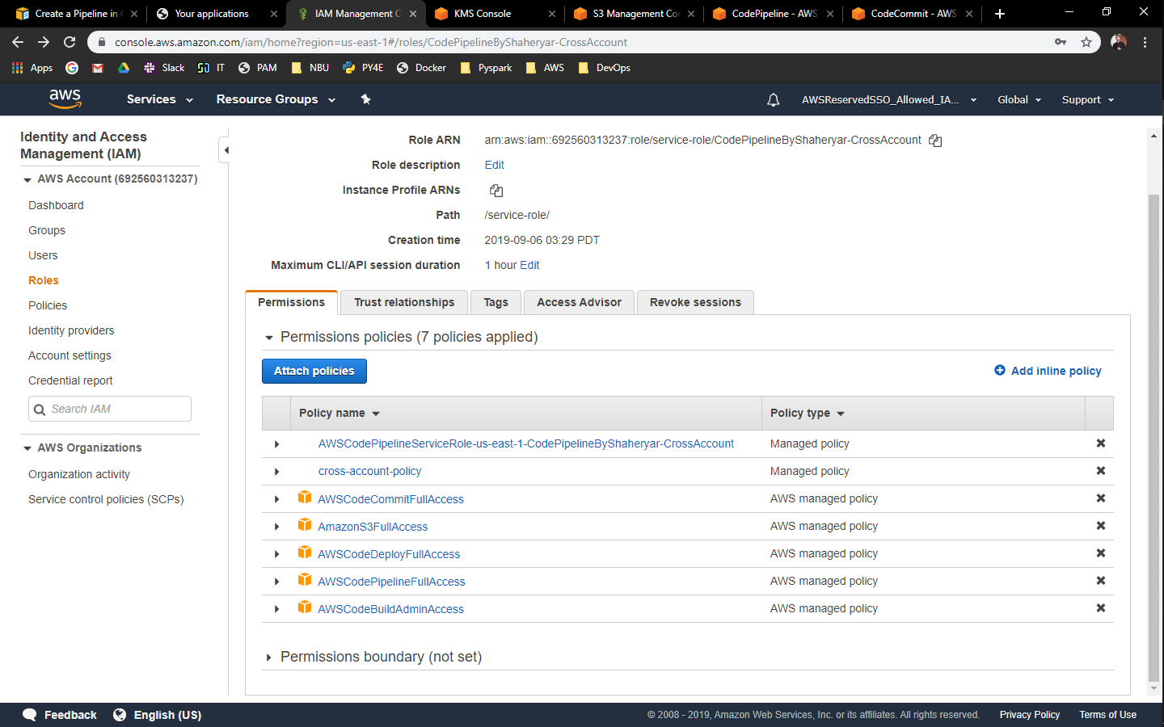

**Policies:**

[AWSCodePipelineServiceRole-us-east-1-CodePipelineByShaheryar-CrossAccount](https://console.aws.amazon.com/iam/home?region=us-east-1#/policies/arn%3Aaws%3Aiam%3A%3A692560313237%3Apolicy%2Fservice-role%2FAWSCodePipelineServiceRole-us-east-1-CodePipelineByShaheryar-CrossAccount)

{

"Statement": [

{

"Action": [

"iam:PassRole"

],

"Resource": "*",

"Effect": "Allow",

"Condition": {

"StringEqualsIfExists": {

"iam:PassedToService": [

"cloudformation.amazonaws.com",

"elasticbeanstalk.amazonaws.com",

"ec2.amazonaws.com",

"ecs-tasks.amazonaws.com"

]

}

}

},

{

"Action": [

"codecommit:CancelUploadArchive",

"codecommit:GetBranch",

"codecommit:GetCommit",

"codecommit:GetUploadArchiveStatus",

"codecommit:UploadArchive"

],

"Resource": "*",

"Effect": "Allow"

},

{

"Action": [

"codedeploy:CreateDeployment",

"codedeploy:GetApplication",

"codedeploy:GetApplicationRevision",

"codedeploy:GetDeployment",

"codedeploy:GetDeploymentConfig",

"codedeploy:RegisterApplicationRevision"

],

"Resource": "*",

"Effect": "Allow"

},

{

"Action": [

"elasticbeanstalk:*",

"ec2:*",

"elasticloadbalancing:*",

"autoscaling:*",

"cloudwatch:*",

"s3:*",

"sns:*",

"cloudformation:*",

"rds:*",

"sqs:*",

"ecs:*"

],

"Resource": "*",

"Effect": "Allow"

},

{

"Action": [

"lambda:InvokeFunction",

"lambda:ListFunctions"

],

"Resource": "*",

"Effect": "Allow"

},

{

"Action": [

"opsworks:CreateDeployment",

"opsworks:DescribeApps",

"opsworks:DescribeCommands",

"opsworks:DescribeDeployments",

"opsworks:DescribeInstances",

"opsworks:DescribeStacks",

"opsworks:UpdateApp",

"opsworks:UpdateStack"

],

"Resource": "*",

"Effect": "Allow"

},

{

"Action": [

"cloudformation:CreateStack",

"cloudformation:DeleteStack",

"cloudformation:DescribeStacks",

"cloudformation:UpdateStack",

"cloudformation:CreateChangeSet",

"cloudformation:DeleteChangeSet",

"cloudformation:DescribeChangeSet",

"cloudformation:ExecuteChangeSet",

"cloudformation:SetStackPolicy",

"cloudformation:ValidateTemplate"

],

"Resource": "*",

"Effect": "Allow"

},

{

"Action": [

"codebuild:BatchGetBuilds",

"codebuild:StartBuild"

],

"Resource": "*",

"Effect": "Allow"

},

{

"Effect": "Allow",

"Action": [

"devicefarm:ListProjects",

"devicefarm:ListDevicePools",

"devicefarm:GetRun",

"devicefarm:GetUpload",

"devicefarm:CreateUpload",

"devicefarm:ScheduleRun"

],

"Resource": "*"

},

{

"Effect": "Allow",

"Action": [

"servicecatalog:ListProvisioningArtifacts",

"servicecatalog:CreateProvisioningArtifact",

"servicecatalog:DescribeProvisioningArtifact",

"servicecatalog:DeleteProvisioningArtifact",

"servicecatalog:UpdateProduct"

],

"Resource": "*"

},

{

"Effect": "Allow",

"Action": [

"cloudformation:ValidateTemplate"

],

"Resource": "*"

},

{

"Effect": "Allow",

"Action": [

"ecr:DescribeImages"

],

"Resource": "*"

}

],

"Version": "2012-10-17"

}

[cross-account-policy](https://console.aws.amazon.com/iam/home?region=us-east-1#/policies/arn%3Aaws%3Aiam%3A%3A692560313237%3Apolicy%2Fcross-account-policy)

{

"Version": "2012-10-17",

"Statement": {

"Effect": "Allow",

"Action": "sts:AssumeRole",

"Resource": [

"arn:aws:iam::373281343701:role/*"

]

}

}

Added these policies as we well:  
https://console.aws.amazon.com/iam/assets/images/policy_icon.png [AWSCodeCommitFullAccess](https://console.aws.amazon.com/iam/home?region=us-east-1#/policies/arn%3Aaws%3Aiam%3A%3Aaws%3Apolicy%2FAWSCodeCommitFullAccess)

https://console.aws.amazon.com/iam/assets/images/policy_icon.png [AmazonS3FullAccess](https://console.aws.amazon.com/iam/home?region=us-east-1#/policies/arn%3Aaws%3Aiam%3A%3Aaws%3Apolicy%2FAmazonS3FullAccess)

https://console.aws.amazon.com/iam/assets/images/policy_icon.png [AWSCodeDeployFullAccess](https://console.aws.amazon.com/iam/home?region=us-east-1#/policies/arn%3Aaws%3Aiam%3A%3Aaws%3Apolicy%2FAWSCodeDeployFullAccess)

https://console.aws.amazon.com/iam/assets/images/policy_icon.png [AWSCodePipelineFullAccess](https://console.aws.amazon.com/iam/home?region=us-east-1#/policies/arn%3Aaws%3Aiam%3A%3Aaws%3Apolicy%2FAWSCodePipelineFullAccess)

https://console.aws.amazon.com/iam/assets/images/policy_icon.png [AWSCodeBuildAdminAccess](https://console.aws.amazon.com/iam/home?region=us-east-1#/policies/arn%3Aaws%3Aiam%3A%3Aaws%3Apolicy%2FAWSCodeBuildAdminAccess)

**Bucket Policy**

{

"Version": "2012-10-17",

"Id": "SSEAndSSLPolicy",

"Statement": [

{

"Sid": "DenyUnEncryptedObjectUploads",

"Effect": "Deny",

"Principal": "*",

"Action": "s3:PutObject",

"Resource": "arn:aws:s3:::codepipeline-us-east-1-shaheryar/*",

"Condition": {

"StringNotEquals": {

"s3:x-amz-server-side-encryption": "aws:kms"

}

}

},

{

"Sid": "DenyInsecureConnections",

"Effect": "Deny",

"Principal": "*",

"Action": "s3:*",

"Resource": "arn:aws:s3:::codepipeline-us-east-1-shaheryar/*",

"Condition": {

"Bool": {

"aws:SecureTransport": "false"

}

}

},

{

"Sid": "",

"Effect": "Allow",

"Principal": {

"AWS": "arn:aws:iam::373281343701:root"

},

"Action": [

"s3:Get*",

"s3:Put*"

],

"Resource": "arn:aws:s3:::codepipeline-us-east-1-shaheryar/*"

},

{

"Sid": "",

"Effect": "Allow",

"Principal": {

"AWS": "arn:aws:iam::373281343701:root"

},

"Action": "s3:ListBucket",

"Resource": "arn:aws:s3:::codepipeline-us-east-1-shaheryar"

}

]

}

**KMS key Setting**

Must have Pipeline Role + Other Account added for Usage

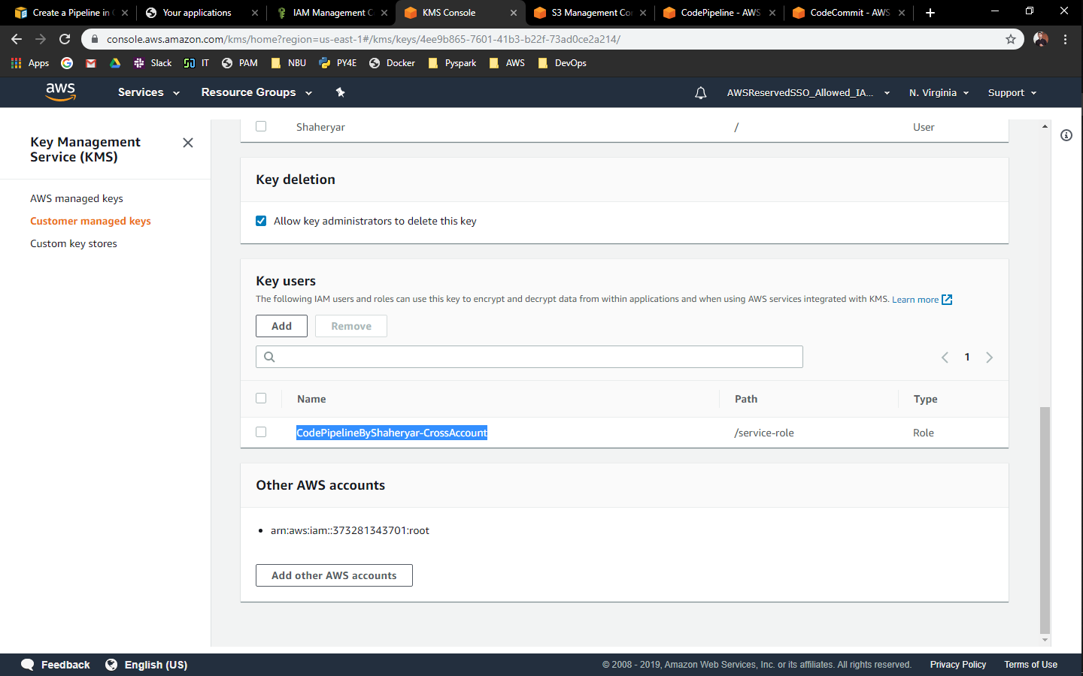

**Pipeline.json**

{

"pipeline": {

"name": "CodePipelineByShaheryar-CrossAccount",

"roleArn": "arn:aws:iam::692560313237:role/service-role/CodePipelineByShaheryar-CrossAccount",

"artifactStore": {

"type": "S3",

"location": "codepipeline-us-east-1-shaheryar",

"encryptionKey": {

"id": "arn:aws:kms:us-east-1:692560313237:key/4ee9b865-7601-41b3-b22f-73ad0ce2a214",

"type": "KMS"

}

},

"stages": [

{

"name": "Source",

"actions": [

{

"name": "Source",

"actionTypeId": {

"category": "Source",

"owner": "AWS",

"provider": "CodeCommit",

"version": "1"

},

"runOrder": 1,

"configuration": {

"BranchName": "master",

"PollForSourceChanges": "false",

"RepositoryName": "cross-account-repo-sh"

},

"outputArtifacts": [

{

"name": "SourceArtifact"

}

],

"inputArtifacts": [],

"region": "us-east-1"

}

]

},

{

"name": "Deploy",

"actions": [

{

"inputArtifacts": [

{

"name": "SourceArtifact"

}

],

"name": "ExternalDeploy",

"actionTypeId": {

"category": "Deploy",

"owner": "AWS",

"version": "1",

"provider": "CodeDeploy"

},

"outputArtifacts": [],

"configuration": {

"ApplicationName": "AhmadCodeDeployApplication",

"DeploymentGroupName": "AhmadCodeDeployApplicationGroup"

},

"runOrder": 1,

"roleArn": "arn:aws:iam::373281343701:role/AhmadCrossAccountRole",

"region": "us-east-1"

}

]

}

],

"version": 1

}

}

**CodeCommit Repo Directory Structure**

